**【Sample】**

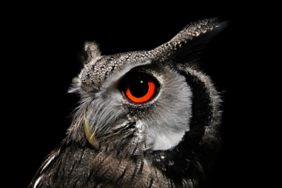 **Peroxiredoxin acts protectively on osteoclasts against oxidative stress when teeth are injured.**

**Prof. Toru Yanagawa**

Professor, Department of Oral and Maxillofacial Surgery, Insutitute of Medicine, University of Tsukuba.

1-1-1 Tennodai, Tsukuba, Ibaraki, 305-8575, JAPAN

e-mail: xxxx@md.tsxxxba.ac.jp

***Objects:*** When teeth are traumatized, the jawbone undergoes oxidative stress due to inflammation and other factors. Peroxiredoxin is a thioredoxin-dependent hydrogen peroxide scavenging enzyme as an antioxidant protein with isoforms I - IV. In the present study, we investigated the effects of oxidative stress on bone using Peroxiredoxin I (Prx I) knockout mice.

***Materials and Methods:*** Prx I knockout mice were generated from ES clones (OST422296: Lexicon Genetics Inc.) using the gene trap method. These mice were compared with wild-type mice by X-ray examination, microfocus CT imaging, bone densitometry by DXA, and bone morphometry. Macrophages were also collected to examine their ability to resist oxidative stress.

***Result:*** Screening by simple radiography revealed no obvious abnormalities, but microfocus CT showed increased bone cortex in Prx I knockout mice, and bone densitometry by DXA showed increased bone density. In addition, bone morphometry showed a decrease in osteoclast count and osteoclast surface.

***Conclusions:*** These results suggest that loss of Prx I in response to trauma-induced oxidative stress may result in bone mutations that are more damaging to the osteoclast lineage.

**Key Words**: Peroxiredoxin, Oxidative stress, Knockout mouse, Bone morphometry, DXA.

**Brief CV**

1999-2010: Assistant Professor, Department of Oral and Maxillofacial Surgery, Institute of Medicine, University of Tsukuba.

2010-2018: Associate Professor, Department of Oral and Maxillofacial Surgery, Institute of Medicine, University of Tsukuba.

2018-present: Professor, Department of Oral and Maxillofacial Surgery, Institute of Medicine, University of Tsukuba. Ibaraki Clinical Education and Training Center, University of Tsukuba Hospital.